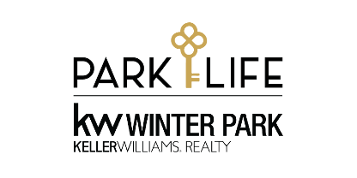
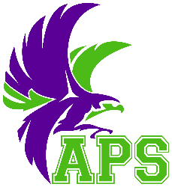
Park Life Falcon 5K Run/Walk
Sponsorship Opportunities
Audubon Park School K8 – February 11, 2023

Gold - $5,000 - SOLD OUT
- Event naming rights. The “your name here” Falcon 5K with rights to Industry Exclusivity.
- Recognition on the school marque for the month leading up to race day
- Recognition banner prominently displayed in the carline for the month leading up to race day
- 10 complimentary event entries (event T-shirts included)
- Ability to provide the awards that athletes receive
- Logo placement on the back of the event T-shirt
- Web banner with hyperlink advertisement on the event website
- Logo with hyperlink on display in Facebook advertising
- Logo with hyperlink on all event specific emails
- 5 PA announcements (Sponsor to provide 30-50 word ads that will be read over the PA system).
- Prominent banner placement at the race venue (banner to be provided by Sponsor).
- Display advertisement in participant packet (provided by Sponsor)
- 10' x 10' booth at the event to promote and sell services and products

Silver - $2,500
- 6 complimentary event entries (event T-shirts included)
- Logo placement on the back of the event T-shirt
- Web banner with hyperlink advertisement on the event website
- Logo with hyperlink on display in Facebook advertising
- Logo with hyperlink on all event specific emails
- 3 PA announcements. (Sponsor to provide 30-50 word ads that will be read over the PA system).
- Banner placement at the race venue (banner to be provided by Sponsor).
- Display advertisement in participant packet (provided by sponsor)
- 10' x 10' booth at the event to promote and sell services and products

Bronze - $1,000
- 4 complimentary event entries (event T-shirts included)
- Logo placement on the back of the event T-shirt
- Web banner with hyperlink advertisement on the event website
- Logo with hyperlink on display in Facebook advertising
- Logo with hyperlink on all event specific emails
- Verbal recognition over the PA system
- Banner placement at the race venue (banner to be provided by Sponsor).
- Display advertisement in participant packet (provided by Sponsor)
- 10' x 10' booth at the event to promote and sell services and products

Water Station - $500 SOLD OUT
- Water Stations will be at Mile 1 and Mile 2. Decorate your station and help pass out water to participants. Each water station must have at least 3 volunteers provided by sponsor. Water, table and supplies to be provided by Audubon Park School.
- Logo placement on the back of the event T-shirt
- Web banner with hyperlink advertisement on the event website
- Logo with hyperlink on display in Facebook advertising
- Logo with hyperlink on all event specific emails
- Verbal recognition over the PA system
- Display advertisement in participant packet (provided by Sponsor)

Booth - $250 (Unlimited Sponsorships)
- Display advertisement in participant packet (provided by Sponsor).
- 10' x 10' booth at the event to promote and sell services and products (provided by the Sponsor)

Participant Packets
We are always in need of 750 small items to include in the competitor swag bags. Advertise your business and support the race with customized lip balm, coffee mug, pen, goodies, or anything you want to see.
- Display advertisement in participant packet (provided by Sponsor)
- Item delivery must arrive to Audubon Park School by Friday, February 3, 2023

Donor
A believer in our cause who won’t be able to race but wants to support us. Any donation amount is greatly appreciated.

*Checks may be made payable to Audubon Park School PTSA
Race contact: Brooke Castino bcastino@cfl.rr.com or 407-284-0024

